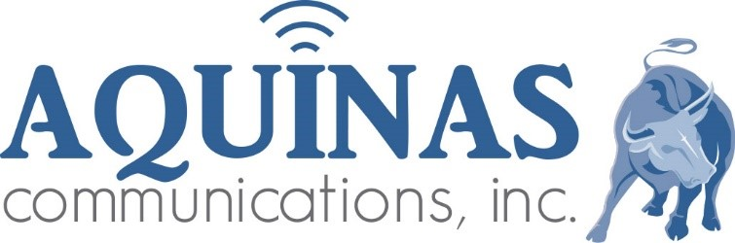 Radio Production Script

Client: FM 98.3 KCRD
Title: Weather Sponsorships by Day
Length: :15
Date: May 1, 2026
Announcer: Jim Vaughn

Intro
The Our Lady of Good Success Radio Network Forecast for Dubuque, Dyersville, Peosta, & Platteville
………..Forecast…………..
Extro
The Our Lady of Good Success Radio Network Forecast is brought to you by:
Monday
Scott Leibfried Stack Stone Wealth, Manders Properties, & Comelec Internet

Tuesday
Graham's Style Store for Men & Women, Manders Properties, & The Michael Bormann Knights of Columbus Insurance Agency
Wednesday
Graham's Style Store for Men & Women, Manders Properties, & The Michael Bormann Knights of Columbus Insurance Agency
Thursday
Hoffmann Schneider & Kitchen Funeral Home Cremation Service, Skip Breitbach Feeds, & Comelec Internet
Friday

Jack’s Chicken & Fish Palace, Molo Plumbing & Heating & The Michael Bormann Knights of Columbus Insurance Agency

Saturday
Jack’s Chicken & Fish Palace, Molo Plumbing & Heating & The Michael Bormann Knights of Columbus Insurance Agency
Sunday

Scott Leibfried Stack Stone Wealth, Manders Properties, & Clarity Clinic

__

__

___

___

